**22TechPark.com– Site Map**

Single Scrolling, Responsive Website

**H1**

**North Atlanta’s Premiere Tech Incubator & Startup Community**

**H2**

**Customizable Workspace Solutions for Tech Startups**

**Other Ideas:**

**Customizable Space for Tech Startups**

**Tech Startup Community – Customizable Workspaces**

**About Occupants Supporters Events Buzz**

___________________________________________________________________

**About**

22TechPark offers technology entrepreneurs a place to create, develop, network, and flourish. Our mission is to provide early stage IT startups with a working environment that is conducive to teamwork, sharing, flexibility, and execution. From a single person pod to a functional team area that grows as you grow, 22TechPark has options for most early stage startups. Located outside of the perimeter on the north end of The Perimeter, 22TechPark is perfectly located for North Atlantans who seek to work closer to where they live.

**Schedule A Tour Today Button & Location Map w. Address**

___________________________________________________________________

**Occupants**

A community of driven IT entrepreneurs connected by a passion to succeed and the willingness to support each other along the way.

**Who works here –** Logos linked to another page that has a summary of all current residents NOT to other websites (see information below)

**Why they work here –** Free Wifi, Free Parking, Yoga Wednesdays, 3pm Refuel Snacks, bi-monthly networking events, Access to Pro Bono Legal Services, Discounted SaaS based Billing/HR Solutions, Discounted AWS Cloud Computing Solutions, Free Cloud Assessments

**You want to work here –** Technology is your business. Community is important to you. You’re a one-man band or have a small team (less than 5). You’re not an A Hole.

___________________________________________________________________

**Supporters**

There are many friends of 22TechPark and we owe them a debt of gratitude. Their mentorship and aid (be it financial or otherwise) continues to make 22TechPark a desirable location for Atlanta based tech entrepreneurs. If you would like to help support our community, reach out to us.

**(Hypothetical) Staples,** **Relus Technologis, Legal, AWS, Grocery Store, Payment Processing, Global Knowledge, Gwinnett County Chamber of Commerce**

**Become a Sponsor – Pardot Form**

___________________________________________________________________

**Events (see example of desired aesthetic and functionality)**

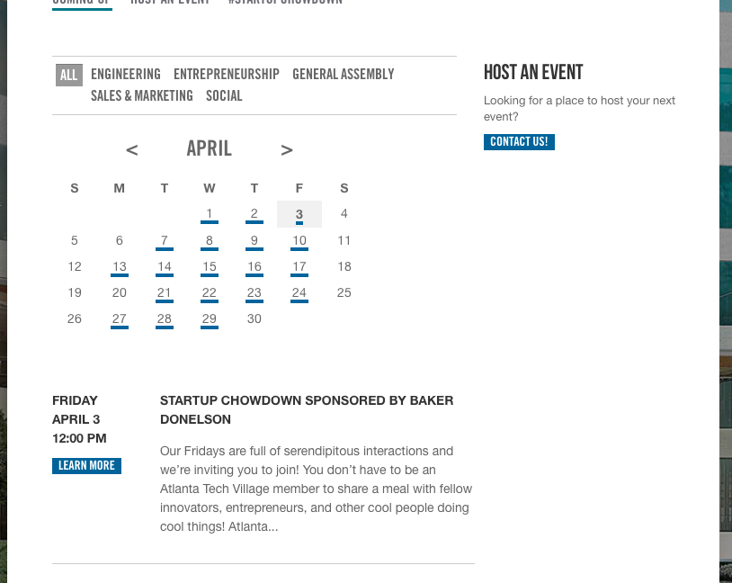

___________________________________________________________________

**Buzz**

**Social Feed**

**Blog Feed**

**Press**

**Video**

___________________________________________________________________

Current Members

ATADATA

http://atadata.com/



FirmDesign

http://www.firmdesign.com/

MotivDeals

http://www.motivdeals.com/



Novarata

http://www.novarata.com/

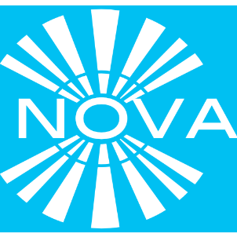

Sonline

http://sonline.us/new/



TekWear

http://www.tekwearag.com/

